**ST. XAVIER’S COLLEGE**

**(Affiliated to Tribhuvan University)**

**Maitighar, Kathmandu**



**SIMULATION AND MODELING LAB REPORT #01**

**SUBMITTED BY:**

Pradeep Dahal

017BSCIT029

3rd year/ 5th sem

|  |  |
| --- | --- |
|  | Signature |
| Mr. Ganesh Yogi  (Lecturer) |  |
| Department of Computer Science | |

**SUBMITTED TO:**

**TITLE: TO SIMULATE THE BROWNIAN MOTION USING EXCEL**

**THEORY:**

Brownian motion of a particle is a result of the thermal motion of the molecular agitation of the liquid medium. Much stronger random displacement of a particle is usually observed in a less viscous liquid, smaller particle size, and higher temperature. A particle of size larger than 1 μm doesn′t show a remarkable Brownian motion. There is much literature available on Brownian motion, and the Brownian motion is regarded as a diffusion process.

For dx, the formula in the excel sheet is given by:

=1-(RAND()*2)

For dy, the formula in the excel sheet is given by:

=1-(RAND()*2)

**RESULT:**

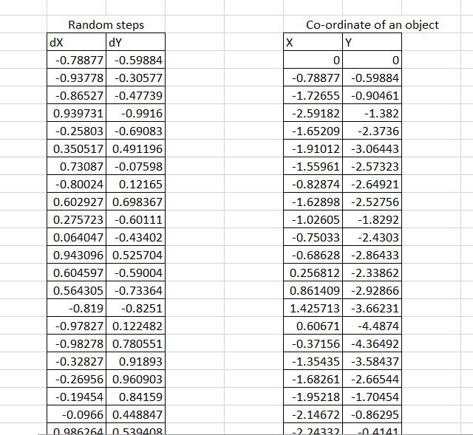

**OBSERVATION OF THE GRAPH:**

**CONCLUSION:**

Hence, the Brownian motion is simulated in the Microsoft excel.